Further Policy Recommendations and Data Analysis in Support of an
Interim Void Policy
in the NYC Water Supply Reservoirs

Prepared by: Catherine L. Magliocchetti
6 Spring Court, Washington Crossing, PA
Masters of Environmental Studies Candidate, University of Pennsylvania

April 2008

Executive Summary

This report attempts to clarify some of the ethical, economic and public policy positions expressed by victims of the major main stem Delaware River flooding that has occurred in recent years. Major flood events occurred in September 2004, April 2005 and June 2006 causing 9 deaths, $226 million in federal flood insurance claim payouts, and an estimated $500 million in total flood damages.

In order to further strengthen arguments for more proactive flood control measures (particularly the suggestion that some percentage of capacity voids be instituted in the three New York City (NYC) water supply reservoirs, Pepacton, Cannonsville and Neversink) this report will explore some policy and planning interpretations on the concept of flood protection, and then discuss some limiting factors in enhancing structural flood improvements, such as retrofitting release works in the reservoirs.

Understandably, but regrettably, since the Delaware River Basin Commission (DRBC) is currently reviewing and preparing response to the Flexible Flow Management Program, requests for certain data from DRBC and the Delaware Rivermaster have yet to be fulfilled, so this report cannot speak with any authority as to either the potential damage that quick, large quantity releases may produce on communities located close to the reservoir outfalls; nor the practicality as to whether enough water could be released with retrofitted release works in order to produce the voids necessary to mitigate flood potential in any significant measure.

Therefore, while the scope of this report has necessarily moved away from the feasibility of retrofit projects until better modeling and cost forecasts are available, the remaining viable flood control option that could immediately be implemented is the use of void space in each of the upstream water supply reservoirs that service NYC. Until the anticipated modeling proposed in the FFMP is available, it would seem a prudent management tool to advocate the inclusion of an interim capacity void in the NYC water supply reservoirs. The inclusion of the voids is not without qualification, and the limited circumstances under which voids should be imposed will be discussed herein. While modeling will provide a better tool for determining future flood protection measures, in the absence of such a tool, it is recommended that use of the Palmer Drought Severity Index (PDSI) be used to assess relative moisture conditions in the region, and that this criteria, combined with National Weather Service (NWS) precipitation forecasting be used to institute spring and summer time releases from the reservoirs if needed.

The use of these two non-biased metrics (e.g., DPSI and NWS forecasts) will be able to assist the down basin Governors in deciding whether or not to call for reservoir releases with the benefit of a scientific basis for such requests in the near term.

Introduction

Many Delaware River Basin (DRB) flood victims are continuing to investigate several policy positions regarding structural flood mitigation measures. While the currently proposed Flexible Flow Management Program (FFMP) remains under internal deliberation and continues to be criticized by members of the DRB community who were affected by the three recent major flood events, we have been exploring the basis for an interim void-based approach for the three water supply reservoirs as has been previously advanced to DRBC through public comment.
A void-based approach is not without its own controversy. As has been debated both internally and externally, the risk of regional drought can and has previously had severe repercussions with respect to not only water supply, but ecological concerns as well. As the DRBC is well aware, drought conditions not only impact the quantity and quality of the New York City (NYC) water supply (servicing approximately 9 million residents of the city and state of New York), but can also impact salinity encroachment, the drinking water supply for approximately 2 million more Pennsylvania and New Jersey residents serviced by water intakes downstream, and the ecological impacts of low-flow conditions for cold-water fishery concerns, the dwarf wedge mussel and other organisms affected by lack of water supply during drought.
Even with the above mentioned concerns however, there are many who continue to search for alternatives to the current management of the basin’s headwaters. While void implementation still confronts a big political obstacle due to NYC’s overwhelming water supply concerns and its veto-power among the Decree parties, from a practical standpoint, voids could easily be instituted within the water supply reservoirs, and add a measure of flood protection not currently available.

It should be noted that this concept is not entirely without some political proponents, as Congressman Patrick Murphy (D-8th District, Pennsylvania) has recently espoused in a letter to at least one constituent on the topic:
An immediate action that should be taken in the meantime is to better manage the up stream reservoirs. While New York's Delaware River reservoirs were not originally designed as flood mitigation tools, it is clear that changes to the reservoirs' operation could significantly reduce flood damages downstream. For this reason, I have repeatedly urged the four governors in the Delaware Basin, as well as the City of New York, to take the significant but necessary step of maintaining sufficient room in the reservoirs to protect against flooding downstream.
Further, Governor Edward Rendell (D-Pennsylvania) has also given credence to this approach, through his recent request of NYC to lower the water supply reservoirs by approximately 8 billion gallons, citing concerns of spilling reservoirs and wetter-than-normal precipitation for the months of February and March 2008. Following agreement of the April releases by the Decree parties, Governor Rendell commented as follows:
I'm pleased and encouraged that New York City and the other parties agreed to take this precautionary step to better protect our communities along the Delaware River. While we can't scientifically quantify the benefits lowering these reservoirs will have, continuing to make releases beyond when the reservoirs are at full capacity, as they are now, is a commonsense approach that will provide an added measure of comfort to residents downstream.

While political sentiment among those representing downstream residents does appear to be swaying in favor of more void capacity than currently proposed under the FFMP, the concern that this type of release is irresponsible (in terms of drought mitigation) needs to be addressed from a watershed management perspective. It is within that context that we have attempted to cull some further scientific data on the issue, and offer the use of this as justification for water supply releases and to scientifically analyze the “commonsense approach” suggested in the Governor’s statement.

As the above statements indicate a potential for political coalescence on the issue of voids in the reservoir system, some flood victims feel a more formal, scientific review of known environmental indicators can be used to aid decision-makers in the process of deciding when and how much water should be released from the upstream water supply reservoirs. It is surprising that the notion of using the well-known and easily accessible Palmer Drought Severity Index (PDSI) has not yet been advanced by those familiar with this issue. While as with any type of environmental data set, the PDSI has its limitations, it would seem to be a prime and useful tool to aid in deciding whether the region is susceptible to potential flood events, the likes of which we have seen in the major flooding that occurred in September 2004, April 2005 and June 2006. As noted in the DRB Interstate Flood Mitigation Task Force Action Agenda, a review of the conditions preceding each of the flood events concluded that the level of antecedent moisture, combined with the occurrence of high intensity and long duration precipitation events, led to major flood events that were statistically abnormal occurrences. When one considers however, that those same antecedent conditions exist today, as measured by the PDSI; and when the NWS has issued its forecast for a wetter-than-normal spring, why then (setting aside NYC’s legal right to maintain the water supply reservoirs at full capacity or even with spilling conditions) would DBRC and others not do more to persuade NYC to voluntarily lower the reservoirs proactively to assuage some flood potential within the downstream region. More will be discussed below on the history, basis and current projections of the PDSI and the NWS, and how these tools may be used to better fortify (or dismiss) future calls to lower reservoir levels. It is suggested that these types of commonly-accessible tools will lend transparency and credibility to implementation of a void approach, well beyond what is suggested in the FFMP, in the near future.

Flood Mitigation Policy and Proposals

Before proceeding to the option of using scientific metrics for decision-making on void inclusion in the reservoir system, however, the following topics will be further discussed in order to present a more comprehensive discussion as to why more effort should be spent to mitigate future flood damage along the main stem Delaware River.

Among the issues to further be explored:
◦ the heretofore responsive nature of the DRB Compact, and the recognition that issues previously unforeseen by the Supreme Court Decree can be negotiated within the context of the Commission framework
◦ the potential for the DRB Compact to be challenged by downstream states, if future conditions make flood events (including increased frequency of flood action stages and actual flood conditions) continue to occur on an increasing frequency
◦ the arguable nature of interbasin water transfers, and whether current ecological understanding and legal interpretations would continue to support the mass transfer of water resources to areas outside of the water basin, when other sources are available and technological advances in water treatment would make their availability more feasible
◦ the notion that responsible water resource management could better mitigate against potential flood hazards through void inclusion, if NYC were to more responsibly manage the supply by spending money to correct leaking infrastructure, pursue alternative sources by adding filtration capabilities to its supply system, and continue to enhance its conservation efforts among NYC residents
◦ why the water supply reservoirs are not already required to maintain flood safety voids, and the historical context of the Tock’s Island Dam project within DRBC’s Comprehensive Plan,
◦ the political and physical impediments to constructing additional reservoirs on the Delaware River, either to increase water supply or act as a flood mitigation tool, and
◦ the direct, indirect and infrastructure-related costs associated with flood events.

Even though some will continue to argue that no type of relief involving reservoir voids should be extended to mitigate the risks of those who have knowingly chosen to live in the flood plain, many proponents of void inclusion continue to believe the above-mentioned topics provide several arguments worthy of consideration that would suggest otherwise. If these factions are able to convince elected officials as to the merit of their arguments, there exists the real possibility that failure of the FFMP to provide more substantial flood mitigation measures could lead to a potential restructuring of how the DRB is managed. It is not outside the realm of possibility that the occurrence of a fourth major flood could ignite the potential of a down basin state to challenge the legitimacy of the Compact as it stands, the equitable apportionment of the waters, and the adverse impact that NYC’s veto power on reservoir levels has wrought on downstream communities that could have been spared some amount of damage if voids had been in place during the previous three flood events.

Discussion:
Balancing Drought Prevention against Flood Mitigation -- Can the Framework of the DRB Compact Address these Divergent Goals?

As has recently been pointed out, one of the unique aspects of the DRBC has been its ability to adapt, but not sever the DRB Compact. In responding to the many ecological concerns not previously anticipated when the Compact was created in 1961, the four basin states, the City of New York, and the federal representative to the Commission have been able to address and conquer many hurdles that could not possibly have been anticipated when DRBC was created in 1961. It does appear that public sentiment and political clout will add the issue of flood mitigation to this history. All parties in this debate might do well to be reminded that the ‘bend, not break’ mentality of the Compact has been its strength, and has allowed for many a previous controversial issue (such as amendments to the downstream release policy) to be addressed. While some may not believe a challenge to the 1954 Supreme Court Decree is likely, it should be reiterated to all parties, particularly to NYC representation, that Article X of the Amended Decree dated June 7, 1954 reads:

X. RETENTION OF JURISDICTION; NO ESTOPPEL. Any of the parties hereto, complainant, defendants, or interveners, may apply at the foot of this decree for other or further action or relief, and this Court retains jurisdiction of the suit for the purpose of any order or direction or modification of this decree, or any supplemental decree that it may deem at any time to be proper in relation to the subject matter in controversy. The fact that a party to this cause has not filed exceptions to the report of the Special Master or to the provisions of this decree shall not estop such party at any time in the future from applying for a modification of the provisions of this decree, notwithstanding any action taken by any party under the terms of this decree.

It is not unforeseeable in this climate and under current circumstances that one or more of the downstream states, Pennsylvania, in particular, may choose to revisit the original Decree decision. If a fourth major flood were to occur within the next several months, or even in the next few years, with the extent and scope of damage previously experienced, one might expect even more momentum from the flood victim groups to advance their agenda with elected officials. In that context, the proponents of full-reservoirs-at-any-cost approach may want to consider that a) the 800 mgd allowance (which has never been fully utilized by NYC and which continues to decrease as a result of increased conservation measures) might be subject to a revisiting and downgrading based upon historic use patterns, and b) the fairness and the worthiness of interbasin water transfer from a sustainable ecosystem perspective may today be viewed in a much different light, not only by environmental advocates, but by the Court as well. Proponents of the full spring and summer reservoir approach, even in the circumstance of wet conditions and further predicted precipitation, may be persuaded to at least negotiate the point, when presented with the following arguments from the flood mitigation side.
The amount of water being wasted on a daily basis due to leaking infrastructure needs to be immediately addressed by NYC. According to the NY Department of Environmental Protection’s own reports, every day up to 36 million gallons of water from the Delaware reservoirs are lost due to leaking infrastructure. It is difficult, at best, to argue that the reservoirs need to be full when the supply system itself wastes such enormous quantities of this precious resource. The DRBC should not be put in the position of having to tell flood victims that reservoirs need to be as high as they possibly can in the spring and summer months, only to have much of the water delivered from these impoundments lost in transit to the NYC distribution system. This does not seem to be a politically defensible position, and it would seem that elected officials from down basin states may want to have these issues addressed when negotiating with NYC on the void proposal.
In addition to the rampant loss of water supply through failing infrastructure, one can also argue that the historic ability of NYC to provide its residents with a clean, cheap water supply has led to inefficient use of this resource at the individual level. Each day, NYC residents use approximately 140 gallons of water per person, fifty percent of which routinely comes from the Delaware reservoir system. While not grossly out of line with the average American’s daily usage of water, it is an area ripe for improvement in NYC as well as the country. As with many other current practices, as the nation and the world enter the unforeseen challenges which will be presented with continued Global Climate Change, resource allocation will be a key area of debate. NYC and the DRB would do well to begin implementation of more sustainable, conservation-minded practices that might also serve the purpose of providing flood mitigation in the short term. Better management of current resources should not necessarily mean that NYC continue to hoard all the water it possibly can, even when the presence of flood precursor conditions are present (e.g., wetter than normal soil conditions, predictions of heavy precipitation, dormant vegetation with less uptake capability, etc.). Rather, NYC should recognize that the flood victims of yesterday are its future allies (or at least compatriots) when the droughts of tomorrow are sure to reappear. If cooperative relations are to be maintained within the DRB, NYC needs to be more responsive and respectful of a void policy that can serve dual purposes of water supply and flood mitigation.
For too long, and as evidenced by recent occurrence, the three flooding events have exposed the notion that NYC is balancing its clean, cheap supply of water from the DRB on the backs of Delaware River watershed residents who are most adversely impacted by the inability of the system to use the water supply reservoirs in a responsible manner. While the Decree gives NYC the right to take up to 800 mgd from the Delaware reservoirs, it is not unthinkable that down basin states might challenge this apportionment in the context of today’s commonly understood ecological standards and the adverse impact of flooding on downstream communities. Those who contend that full reservoirs serve downstream residents by also allowing for maintenance of the Montague target (1750 cfs) during low-flow conditions should consider that if the reservoirs did not exist to begin with, the Montague target would not be necessary in the first place. The construct of reservoir-based water supplies is well rooted in history and not without elegance of design or implementation. However, as their existence serves a societal need (to provide water for the masses), they can and should also provide other societal needs whenever possible (such as providing capacity for the flood that could potentially be mitigated by their existence as well).
Comparing the compensating release potential of the reservoir against flood mitigation, there would seem to be an inherent disconnect in the management of the overall system. Surely if the concerns of downstream communities were insignificant, a compensating release objective would not be required. However, the compensating releases are designed with the sole intent of protecting downstream interests against low-flow conditions that can potentially be created by impoundment of the river’s headwaters. If it is recognized that downstream communities’ interests are important in this regard, then flood mitigation should be no less compelling a reason to better manage the reservoir capacities.
The question as to why NYC should be entitled to 800 mgd from the DRB is one that can fairly be reopened in the context of the recent flooding. As NYC has been able to add more treatment capability to its overall supply, through filtration of the Croton system, it should attempt to relieve the overwhelming pressure on the Delaware system and provide for some measure of flood protection for its downstream neighbors. Further, while great strides have been realized in the area of water conservation, much more is needed to remove such an impetus to keep reservoirs at levels by which they routinely spill over their impoundments, weakening their structures and degrading the overall quality of the water flow by adding warm water releases to an already stressed river community.
Lastly, to the point of equitable apportionment and stewardship of this precious resource, the hubris exhibited by the NY DEP on this point in particular, is staggering to say the least. Whereas NY DEP will maintain for the purposes of discussion on void policy that the reservoir system water is simply too important a resource to be lost in the interest of protecting downstream residents against any flood event, the NY DEP is quoted as follows in a 2005 NY Auditor General report, with respect to its own leaking infrastructure issues, which are estimated to amount to 30 - 35 million gallons per day (the equivalent of
$24 - $28 M worth of water at 2005 metered rates):
DEP officials believe a value should not be assigned to this lost water because water supplies are more than sufficient to meet the demands of the system’s customers. They note that the New York City water system is designed with generous watersheds that allow it to collect sufficient water to withstand
periods of drought. For this reason, the water lost in the leaks has no “value.” However, we [the NY Comptroller’s office] note that current water loss comes from within DEP’s RWB tunnel, and that conditions can change. For example, if there were an extended and unusually severe drought in the region, this lost water could become very valuable.
Why NYC Water Supply Reservoirs Do Not Provide Freeboard Protection

According to comments provided to the DRBC on the FFMP, the Flood Control Act of 1965 requires that reservoirs or dams constructed using Army Corps of Engineers standards, contain a designed void, called “freeboard.” It is not only interesting, but somewhat perplexing that the safe design and construction of a water impoundment would seemingly be dictated by whom it is who paid for the construction of the structure, not by an objective set of engineering standards. Given that the construction of the Pepacton, Cannonsville and Neversink reservoirs were intended to serve one public goal, it would not seem counterintuitive that the reservoirs could be used to serve a dual public purpose: water supply and flood control to enhance the structure’s benefit to society at large – both those living outside the watershed and benefiting from supply, and those living downstream, in the basin, who could potentially be afforded some measure of flood protection by their existence.
Moreover, in the context of water resource management in the DRB, the notion of a dam that would have provided for flood control was proposed in the 1960’s, through the Tock’s Island Dam project. While various reasons are to blame (or to credit) for the abandonment of the Tock’s project, it is important to note that the flood control component of the project was originally called for in the DRBC’s Comprehensive Plan,. Without the existence of the project, there does not seem to be a good answer to how DRBC has moved the interests of flood control forward. While the necessity of DRBC to provide for flood protection is discussed under Section 6.1 of the DRBC’s General Powers, it is not clear what measures have been taken by DRBC, “as it may deem necessary or desirable for flood damage reduction.” It may have been that the region’s meteorology had predisposed much of DRBC’s operating life to managing against drought. However, the severe nature of flood events, not only from an economic but societal cost cannot be understated and must now also be folded into DRBC’s mandate and raised to a higher level of priority in terms of planning decisions. DRBC must be able to respond to critics who look back to the Tock’s project and ask what material measures does the Commission provide for the system in terms of flood protection. While worthy of discussion and implementation, the Task Force’s suggestions for flood resiliency are important and vital as future floods are inevitable, but should not entirely take the place of specific measures that might mitigate, to the extent practicable, a future flood event that might have been avoided through the imposition of reservoir voids.
While some have also recently proposed that the answer to increased flood protection lies within the construction of a main stem dam, discussion with elected and appointed officials leaves it clear that this option has little viability. The same economic and environmental concerns that led to rejection of the Tock’s project would remain in play, and it is highly unlikely that such a proposal could be advanced in any successful way given the current circumstances. That still leaves however, the flood issue, and the mandate that DRBC do something to help alleviate, where possible, flooding when it inevitably will occur in the future. This is not to say that there is any action that will prevent all flood events in the future. However, the status quo does not do enough to provide any measure of structural flood mitigation or prevention available to downstream interests. This is part of the DRBC mandate and should take a more preeminent role in the DRBC’s coordinated management efforts in the future.

Individual and Societal Losses from Recent Flood Events

As noted in the Comparative Analysis of Flood Insurance Claims in the Delaware River Basin, prepared by the DRBC Operations Staff and posted April 2007, Federal Emergency Management Agency (FEMA) claims from individuals affected by the flooding in 2004, 2005 and 2006 increased with each event and totaled over $226 M. Total property damages from the occurrence of the three events have been estimated at well over $500 M and the loss of nine lives. Table 1 below provides relevant FEMA claim data.
Also relevant to this area of discussion is that while the societal and environmental impacts from drought are severe, as we have all recently witnessed the southeastern United States, particularly in Atlanta, the human and economic cost of flooding is not inconsequential. Those who are directly and indirectly affected by major flood events experience not only personal property loss, but are subjected to devastating personal stresses from the event. It is not unimportant in this discussion that the rapid and successive nature of the three back-to-back-to-back major flood events within the span of less than two years, caused great strain on the communities where these floods occurred. As was discussed in the Task Force Action Agenda, the September 2004 event was somewhat accepted by the community as ‘the natural order’ of things. Those living in the flood plain were mindful that the risk of flooding is inherent in living so closely to the river. However, it was the even more statistically improbably events that occurred in April 2005 and June 2006 that mobilized the community into looking upstream for potential solutions (such as lowering of the reservoirs) that were not previously needed for the purposes of flood protection.

Table 1

Proposal for Voids in Water Supply Reservoirs

The option of including voids in the water supply reservoirs is based upon the principal that even when full, reservoirs can reduce downstream flood crests through the principle of attenuation. If voids exist in these same structures, the attenuation effects appear to be amplified, as seen in Table 2 below. Figure 1 depicts the commonly accepted attenuation curve, which explains how crests can be lessened by structures such as reservoirs. Table 2 below, is suggestive of the notion that even a small percentage void may be able to provide some measure of flood relief and suggests that more can be done from an overall risk-based management of the reservoir system.

Figure 1: Attenuation of water as it travels through the reservoir leads to decreased flood crests
To the point of using flood control voids in the water supply reservoirs, others who have studied and discussed the problem as part of the DRBC’s Flood Advisory Committee have expressed this very same point of view. From the July 13, 2005 FAC minutes:

Mr. Tamm agreed that managing these reservoirs for flood control requires better advanced forecasts. Mr. Nuffer noted that while reservoirs cannot be raised and lowered quickly on an event by event basis, past records can be used to indicate the
Probability of refill and the relative chance that storage will still be available for water supply purposes. Management on a risk basis could allow more flexible use of the reservoir without jeopardizing its intended purpose, and provide for the greatest good.

Practical Impediments in Instituting Reservoir Voids

As has been pointed out, however, the release works at each of the water supply reservoirs are not designed for quick, large quantity releases. While current data is not publicly available from DRBC with respect to the cost of retrofitting the three water supply reservoirs to accomplish such goals, it is assumed for this discussion that the large-scale retrofit project of the Gilboa Dam in New York State is similar in project size to what might be required for retrofitting the Delaware system reservoirs. If one were to compare the approximate cost of $300 M for what is potentially similar retrofit work on the Gilboa Dam, we could extend that project out to all three Delaware projects and conservatively estimate a retrofit of release works to be near $900 M. Of course, the other limiting factor with respect to retrofit work would be time. Large scale work such as this could take decades, and in fact if the Gilboa project is any indication, even if money were readily available to commence such an effort (which is questionable given NYC’s current attitudes towards reservoir maintenance and operations), it would take years to accomplish the type of effort that is needed right now to address immediate forms of flood protection.
Yet another concern that has been routinely raised is the possibility that quick, large volume releases have the potential to damage small, historic, river-based communities located in close proximity to the reservoir structures. Such intentional releases, even if made in response to pre-flood action stages downstream, would not be tolerated by the public, elected officials or the DRBC and should not be considered as a policy option at this time. The removal of this option however, places the suggested void policy in even more prominent a position.
Voids it should be noted, would not be costly to implement and the water lost through void implementation could potentially be recovered through more conservative use and diversification of the supply of water to NYC. While leak repair will be costly to implement, this step should be accomplished not only to make way for a void policy, but also to transfer the real cost of providing clean water to NYC residents. The era of continued subsidy of water and other resources is quickly coming to a close. As with other failing infrastructure, there needs to be recognition of the fact that the mechanical and physical infrastructure of this country’s public works has a maintenance cost attached. The sooner that end-users are exposed to and charge for real costs such as these, the sooner we will begin to substantially develop more conscious use of all resources, not just that of water.

Suggested Conditions for Void Triggering

As discussed above, the Task Force conclusions with respect to pre-flood conditions frame the same preceding conditions for each of the recent major flood events: antecedent conditions in the region were comprised of wetter-than-normal soils, and abnormally high intensity rainfall was experienced in the region following these conditions.
Looking back at each of the three events, it appears as if very similar preceding events occurred. The region was wet, and getting wetter, and no additional relief short of normal attenuation from a full reservoir could be realized.
While drought conditions have been experienced quite frequently in the DRB during the tenure of the Commission (see Table 3), it is not outside the realm of possibility that the region has within the last several years entered an historically wetter-than-normal condition. Data which suggests that this is the case will be discussed below in the context of reviewing graphical Palmer Drought Severity Index for historic drought, flood and present time periods.

Table 3 – Historical Drought Conditions in the DRB

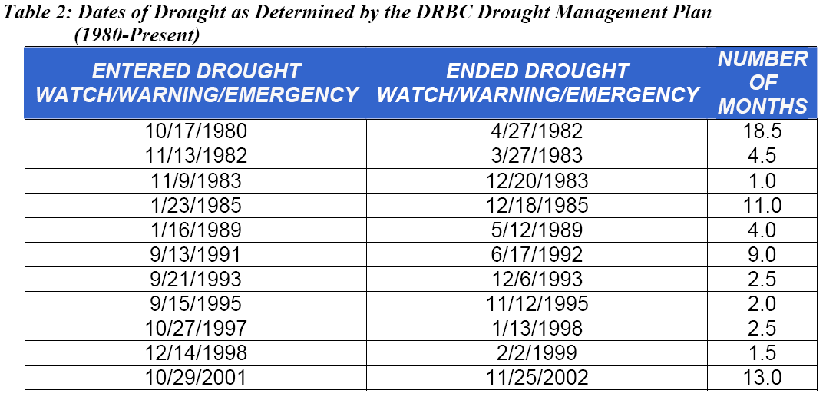

Yet another concern that has recently been raised by the DRBC Executive Director and others, is the idea that some climatologists have suggested that as we enter into weather patterns that are influenced by Global Climate Change (GCC), the northeastern United States will likely experience more frequent, longer duration, higher intensity storms than have been experienced in the last several decades. While impacts from GCC similarly may call into question the increased intensity and impacts of drought conditions as well, it is clear that management of the DRB watershed must use available technology and data to more nimbly respond to all water-based issues, with both drought and flood protection having a bonafide set of stakeholders.
Much can and has been stated in the discussions regarding void inclusion on the unpredictability of impending droughts. As surely as the eventuality of a drought is certain, it is difficult to predict when the next cycle of drier than normal conditions will in fact occur. However, one measure of drought condition that heretofore has been missing from the debate is the well-established existence of the Palmer Drought Severity Index (DPSI). According to the National Oceanographic and Atmospheric Administration (NOAA), it is the ‘semi-official’ drought index and it uses temperature as well as rainfall data to determine the relative dryness of an area. While its utility lies most effectively in the purpose of determining long-term drought conditions (i.e., conditions that extend over a period of several months), it still appears to be an acceptable surrogate for determining wetness of the DRB region, particularly when one reviews its reading for the preceding months of each drought event.
In researching this area, the author was able to access the DPSI link on NOAA’s website, and run several scenarios that gave useful background data for comparison to previously known drought conditions as well as flood conditions. As was expected, DPSI information depicted drier than normal conditions for the 12-months preceding drought conditions in the DRB. Just as importantly, wetter-than-normal conditions were confirmed by studying the graphical data provided for the months preceding the September 2004, April 2005 and June 2006 events. This type of analysis could provide some frame of reference for decision-making on void policy in the future. It can provide a needed source of data to confirm whether pre-existing soil conditions are susceptible to flooding, given the right amount of rainfall.
It is important to note that the review of the DPSI has thus far been qualitative in nature (e.g., one can get a sense from looking at the maps that wetter or drier conditions were experienced in the region over specified periods of time). This is only the first step in analyzing this data, and there should be more study in this area to determine how and if quantitative approaches to void inclusion could be linked to the DPSI. For example, if the DRB were to experience x, y or z number of weeks or months on the moderately, very or extremely moist side of the curve, this could be suggestive of a trigger to lower reservoirs by some predetermined percentage. According to the DRBC, more work is being done to assess the impact that such voids can potentially have on downstream flood crests, and we should work to include those assessments in the discussion. Use of the DPSI could provide watershed managers and elected or appointed officials a scientifically-based rationale for lowering or maintaining reservoirs in concert with future precipitation predictions from the NWS.

Appendix A provides actual input parameters and graphical output from the NOAA PDSI link, http://lwf.ncdc.noaa.gov/oa/climate/research/drought/palmer-maps/
for the following periods of interest and known drought and flood occurrences:

Timeframe of Interest | Known Event | Does PDSI Provide Predictive Value with Respect to the Occurrence of a Known Event?
Jan 1964 – Dec 1965 | Severe Drought Conditions | Y
Oct 1979 – Oct 1980 | Conditions 1 year prior to entering 18.5 month drought condition in Oct 1980 | Y
Nov 1981 – Nov 1982 | Conditions 1 year prior to entering 4.5 month drought condition in Nov 1982 | Y
Sept 1990 – Sept 1991 | Conditions 1 year prior to entering 9.0 month drought condition in Sept 1991 | Y
Oct 2000 – Oct 2001 | Conditions 1 year prior to entering 13 month drought condition in Oct 2001 | Y
Sept 2003 – Sept 2004 | Conditions 1 year prior to major main stem flood event | Sept and April events appear to have correlation with potential flood conditions, June event is difficult to predict using qualitative standards, but more robust analysis may prove or disprove a connection.
Apr 2004 – Apr 2005 | Conditions 1 year prior to major main stem flood event
June 2005 – June 2006 | Conditions 1 year prior to major main stem flood event

Should Inherent Uncertainties with Precipitation Predictions Prevent Their Use as a Watershed Management Tool?

Even more GIS-based tools are cropping up from the NWS, with data analysis relating to Flood Outlooks and more refined short and long-term precipitation forecasting. Even with the relative uncertainty attached to meteorology and weather forecasting, it is unfortunate that DRBC has not yet moved to rely on the vast availability of these data in developing a more comprehensive management plan for flood protection. As has been discussed, the modeling efforts now underway are impressive, well-funded and generally accepted as holding promise for future planning exercises. However, until that tool is developed, DRBC should consider the utility of looking at information that is already available. This approach would lend scientific credibility to the “commonsense” notion that many long time flood victims and more recently, Governor Rendell, have worked to advance. If the ground is wet, and the region is anticipated to receive even more rain, there must be some recognition that voids in the reservoirs might prevent or mitigate a flood occurrence that might otherwise happen. A review of both the DPSI in consultation with the NWS may be able to provide the type of rational, measured approach to better management that would serve both the supply and flood concerns.
Such types of data that are available from NWS are pictured here, including
Map 1: National 6 – 10 day Precipitation Outlook (green signifies above normal)
Map 2: National 3 months Precipitation Outlook (white signifies ‘equal chance’)
Map 3: Combination of 1 and 3 month Temperature and Precipitation Outlooks
Map 4: US Seasonal Drought Outlook

It is noted that this information could potentially be used in conjunction with some type of scoring system for the DPSI to access the utility of void creation for the purpose of flood controls. While modeling efforts are underway and continuing, we would suggest that the combination of these already available data, can provide statistically reliable measures of a void implementation policy in the DRB.

Map 1:
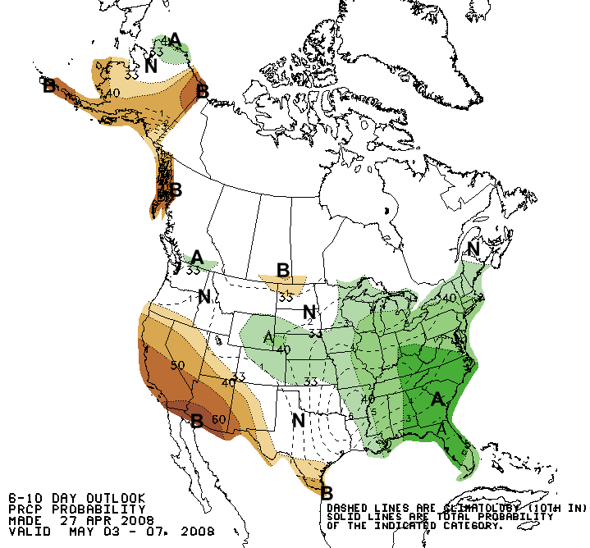
Map 2:
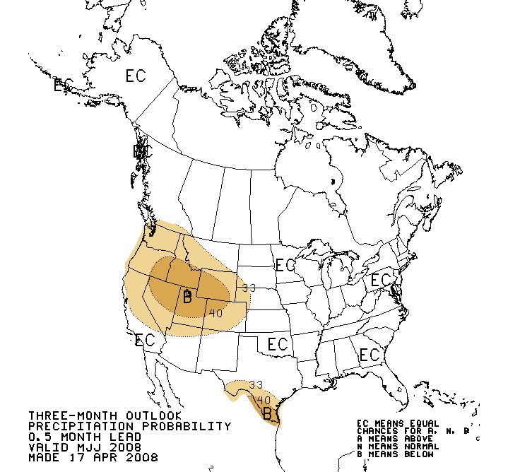

Map 3:

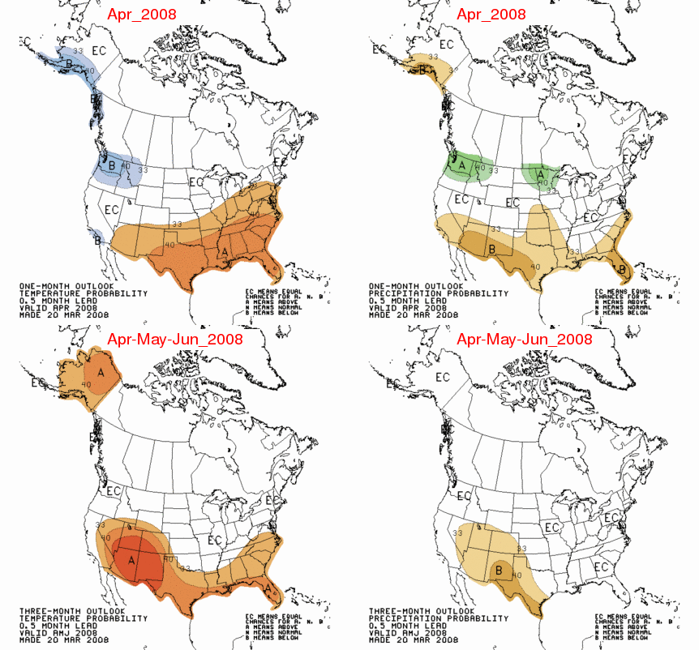

Map 4:

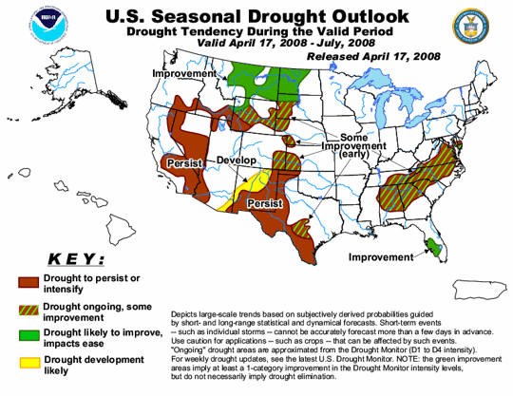

Conclusion
All parties can agree that drought protection is an important aspect of how the DRBC works to manage this shared resource of water. However, the other side of the drought coin is the impact that major flood conditions have on the downstream communities. The above analysis suggests that one component of DRBC’s mission that has not received enough attention or scrutiny has been in the area of flood control. Until such time as modeling tools are available for testing and analysis, the author suggest that we should look to other, well-established and reliable data, which can assist in suggesting policy changes on better reservoir management. The types of tools discussed, primarily the use of the Palmer Drought Severity Index, and forecasting from the National Weather Service, should help the Governors in deciding whether or not to call for uncharacteristic voids in the supply system. While Governor Rendell and the flood victim groups had used a ‘commonsense approach’ to suggest that an 8 billion gallon release might help alleviate some recent concerns, more quantitative metrics are available to support or refute such reactions by elected and appointed officials. In fact, use of these tools could potentially lead to a more structured approach for void releases, where routine monitoring of these criteria would trigger a release from the reservoirs. This approach would seem more responsive than the release curves proposed in the FFMP, which are capacity based and do not account for environmental conditions or predicted weather patterns.
The question of how large a void is yet another area that we hope future modeling can answer. While the 20 % year-round void does not appear likely for political as well as practical management concerns, DRBC should be looking to create viable, reasonable links to soil and weather conditions in relation to the amount of water that could be attenuated in the reservoirs in the case of another major flood event. Even though NYC may not agree with this approach, staff at the DRBC and policy makers in the down basin states should look to providing their decision-makers with more robust arguments that would serve some level of flood protection, as is mandated in the original DRB Compact. Short of that approach, we can and should continue to press for better implementation of the Task Force’s suggested “resiliency” efforts in downstream communities, and as a last resort, pray for the rain to stop when the river is high and reservoirs are spilling.

Citations:

Allocation of the waters in the upper basin is governed by a decree of the U.S. Supreme Court, issued in 1954 to settle an interstate water dispute between New York and the lower basin states which centered on the New York City Delaware Basin reservoirs. The parties to the Supreme Court decree ("decree parties") are the four basin states (Delaware, New Jersey, New York, and Pennsylvania) and the City of New York. The 1954 decree allows New York City to export up to 800 million gallons per day from its three Delaware Basin reservoirs for water supply purposes, provided that compensating releases from those reservoirs are made (when necessary) to maintain a prescribed minimum flow at Montague, New Jersey for the use of the lower basin states. The 1954 decree made no provision for spill mitigation, conservation or ecological releases. http://www.nj.gov/drbc/Res-Fisheries.htm
A 36 mgd loss is equivalent to NYC creating a 5% void in the 270 bg capacity of the three reservoirs on a yearly basis (i.e., at this rate of loss, it takes approximately 375 days for 13.5 bg to leak from the system)
The 1975 decision by the DRBC to defer the Tocks Island Dam decision, the Scenic River designation of the main stem Delaware, and Congressional deauthorization of the Tock’s Island project, left the middle and lower river without the flood control once envisioned in the original Comprehensive Plan of the DRBC…. Although de-authorized by Congress, and not spoken to in the new Basin Water Resources Plan, the Tocks Island project still remains in the DRBC Comprehensive Plan. A policy on main stem flood control projects would set a clear direction for future flood loss reduction measures – whether to control main stem flooding by large structures, or rely instead on spill mitigation at existing reservoirs, floodplain management, stormwater management, and adaptive measures to reduce flood damage.
Correspondence addressed to Catherine L. Magliocchetti, from Congressman Patrick Murphy, April 16, 2008. April 16, 2008 Ms. Catherine Magliocchetti 6 Spring Ct Washington Crossing, PA 18977 Dear Ms. Magliocchetti: For too long, in our community, storms would come and go and people would be left to fend for themselves. When I was sworn into Congress I said, "Let's stop talking about flooding and start doing something about it." That's why I wanted to take this opportunity to send you an update on my ongoing efforts to improve flood prevention, mitigation and recovery along the Delaware River. As you know all too well, after three major floods in three years, too many are still putting the pieces of their homes and businesses back together. By continuing to work together, we can prevent catastrophic damage and fight for flood victims. After a storm, families and business owners too often find a maze of bureaucracy instead of the help they need. Last year in Congress, I introduced and passed a measure to fix this problem and help flood victims by establishing a National Flood Insurance Advocate - someone flood victims could turn to during times of need. Modeled after the successful Taxpayer Advocate Service at the IRS, the Flood Insurance Advocate would help families and businesses cut through the red tape and navigate the bureaucracy of FEMA and their flood insurance companies. Currently, I am working with Senator Casey to ensure that the Senate also approves the creation of this important office when it finalizes the Flood Insurance and Modernization Act of 2007. Securing federal funding is another important task for increasing flood prevention and recovery operations in our area. Over the last year, I led a bipartisan effort to demand funding for these key operations after President Bush zeroed out the programs. We were able to secure $30 million to be used by local flood agencies to remove flood prone homes and businesses from flood zones, elevating properties to eliminate flood damage, and flood-proofing additional structures. Additionally, I continue to work with the Army Corps of Engineers, the United States Geological Service and the National Weather Service to create a computer model of the Delaware River Basin. I am hopeful that this model will provide much-needed information and will lead to the creation of informed and effective policies to protect those who live along the river, and those who rely on it for drinking water. The unfortunate reality, however, is that this study will take more time than those living along the river can afford to lose. An immediate action that should be taken in the meantime is to better manage the up stream reservoirs. While New York's Delaware River reservoirs were not originally designed as flood mitigation tools, it is clear that changes to the reservoirs' operation could significantly reduce flood damages downstream. For this reason, I have repeatedly urged the four governors in the Delaware Basin, as well as the City of New York, to take the significant but necessary step of maintaining sufficient room in the reservoirs to protect against flooding downstream. The fight against flooding is not an easy battle, but I believe that together we can make '100 year' floods true to their name, rather than having one every year. These projects are just the start of the fight and you can be sure that I will continue to work hard both in Washington and here at home to solve this devastating problem and protect Bucks County families from even more hardship. With the help of my Flood Advisory Board, a group of local officials organized to advise on flooding issues, we will continue to seek out and implement additional measures to address flooding problems in heavily affected areas of Bucks County. To stay informed of my work, or for more information about important flood mitigation effort please visit my website at http://www.patrickmurphy.house.gov. Finally, please do not hesitate to contact me again if I can help in any way. You can reach my office in Doylestown at (215) 348-1194 and my office in Bristol at (215) 826-1963. Sincerely, Patrick J. Murphy MEMBER OF CONGRESS
Delaware River Basin Parties Agree to Governor Rendell's Request to Lower NYC Reservoirs Wed Apr 16, 2008 10:45am (Accessed 16 April 2008) http://www.reuters.com/article/pressRelease/idUS170159+16-Apr-2008+PRN20080416
http://www.state.nj.us/drbc/Flood_Website/taskforce/Action-agenda_0707/Final_ActionAgenda0707.pdf
Preparation Underway to Fix Leak in Delaware Aqueduct, March 6, 2008 (Accessed 14 April 2008) http://www.nyc.gov/html/dep/html/press_releases/08-04pr.shtml
OFFICE OF THE NEW YORK STATE COMPTROLLER DIVISION OF STATE GOVERNMENT ACCOUNTABILITY NEW YORK CITY DEPARTMENT OF ENVIRONMENTAL PROTECTION DELAWARE AQUEDUCT SYSTEM: WATER LEAK DETECTION AND REPAIR PROGRAM Thomas P. DiNapoli, COMPTROLLER, Report 2005-N-7, April 2007.
Going Forward: Floodwater Management or Floodplain Management A History of Decisions on the Main Stem Delaware River, Memo by DRBC Staff, October 2006, (Accessed 27 April 2008) http://www.state.nj.us/drbc/Flood_Website/taskforce/GoingForward-Oct2006.pdf
Comparative Analysis of Flood Insurance Claims in the Delaware River Basin September 2004, April 2005 & June 2006 Flood Events, (Accessed 14 April 2008) http://www.state.nj.us/drbc/Flood_Website/NFIPanalysis/CompleteReport3.pdf
A fight Over Taming the Delaware, Anthony DePalma, April 20, 2008 (Accessed 20 April 2008) http://www.nytimes.com/2008/04/20/nyregion/nyregionspecial2/20delawarenj.html
Summary of July 13 DRBC Flood Advisory Committee Meeting, (accessed 23 April 24, 2008) http://nj.gov/drbc/flood_july05.pdf
Carol Collier, DRBC Director, Presentation to the University of Pennsylvania ENVS 627 class on April 21, 2008.
The Palmer Drought Severity Index, (Accessed 24 April 2008), http://www.drought.noaa.gov/palmer.html
NATIONAL WEATHER SERVICE, Significant River Flood Outlook, (Accessed 24 April 2008) http://www.hpc.ncep.noaa.gov/nationalfloodoutlook/index.html
http://www.cpc.ncep.noaa.gov/products/predictions/multi_season/13_seasonal_outlooks/color/p.gif http://www.cpc.noaa.gov/products/predictions/multi_season/13_seasonal_outlooks/color/page2.gif http://www.cpc.ncep.noaa.gov/products/predictions/long_range/lead01/off01_prcp.gif http://www.cpc.ncep.noaa.gov/products/predictions/30day/off14_prcp.gif

